**Assignment4 - Simple particle effect: Snowing**

Since this assignment was based on Tutorial7 I have used it as my refence base code and built my program on top of it. The first I have done is that I had to modify the ParticleSystem.h to create a class called snowflake to initialize the necessary functionalities and properties of a snowflake such as gravity, speed force, size position etc. of course I had to decide which properties had to be private or public.

Example code:

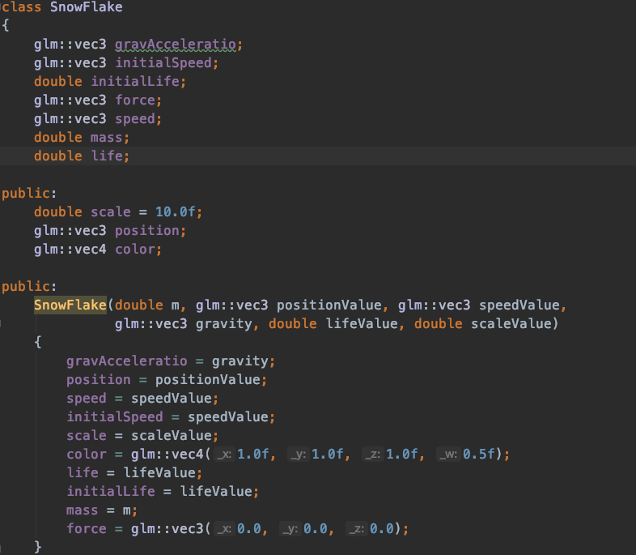

The assignment wanted us to use different size so I have used the rand() function within the width so each time it would display a different size of snowflake. Of this will be done in an increasing while loop.



Also I had to create an array to setup the mesh and contain the attribute properties for the particles and the background image.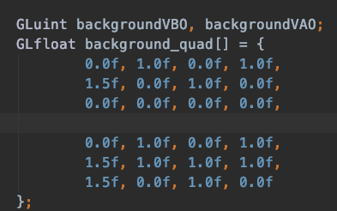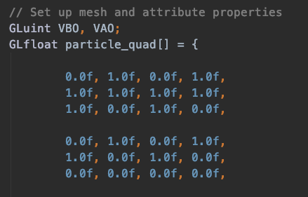

Lastly every second passed in the program I had to make sure that the snowflake had to increase divisible by 200 then increase the snowflake.